# Mindset Week 8

Culture and decision making in team dynamics

We are already aware of PNI, Positional vs Generative, types of bad listeners.

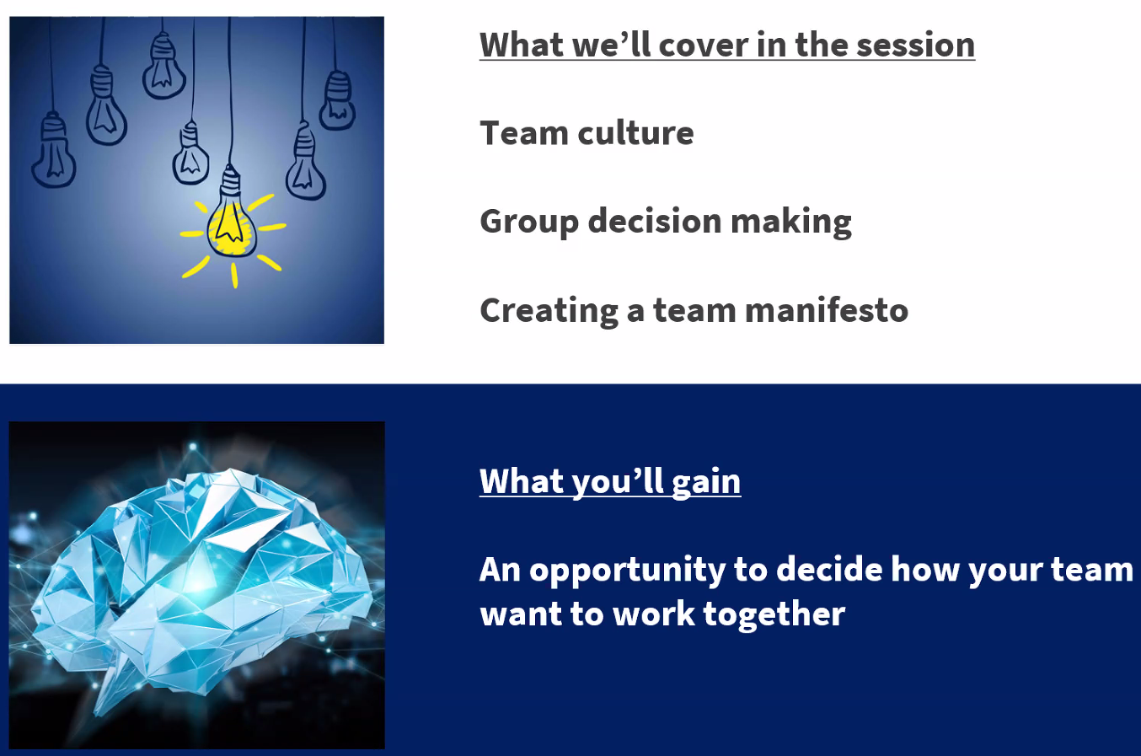

Consider these contrasting culture codes:

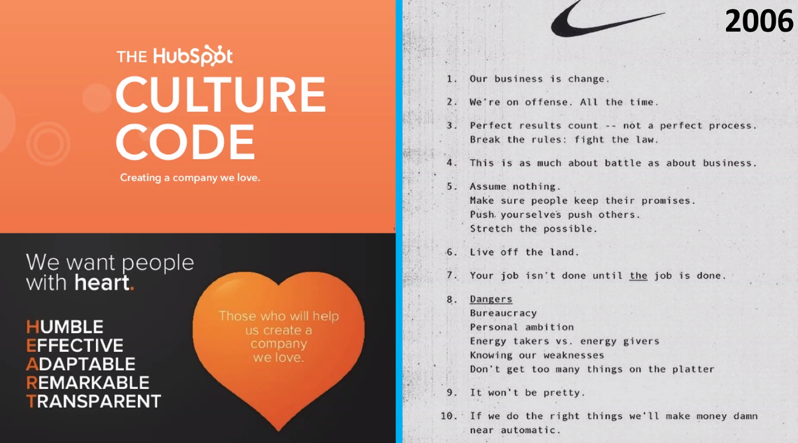

Neither is necessarily right or wrong, but think about how different they are!

Joseph mentioned enjoying working in a team that was fast, a bit of a battle, it was exhausting but the teamwork was top quality – but this isn’t for everyone! It’s a group call.

“Speak up at the back – we’re all listening” – a way of encouraging quieter members of the team to share their opinions.

We were asked to think about these questions and make a list:

* Think about a successful team that you’ve been in (that you enjoyed being a part of)
* What made it a good team?
* List of principles/guidelines/rules

Google’s Project Aristotle – the critical factor to team performance

They looked across thousands of teams to find out what makes a high performing team. One thing was critical – **psychological safety**.

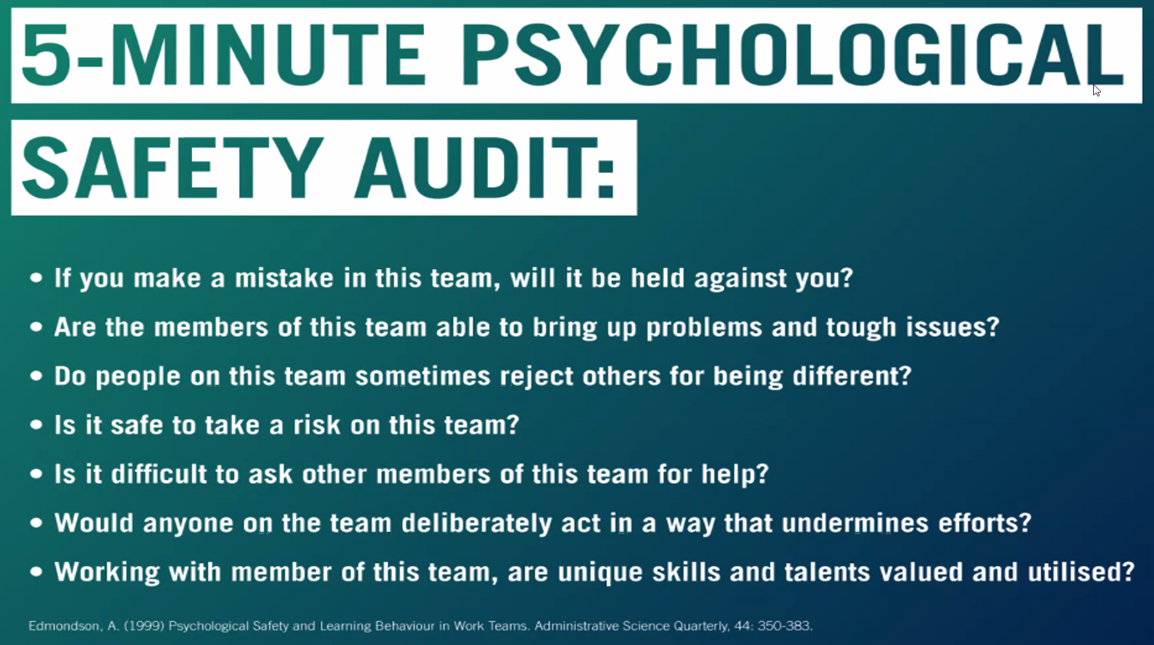

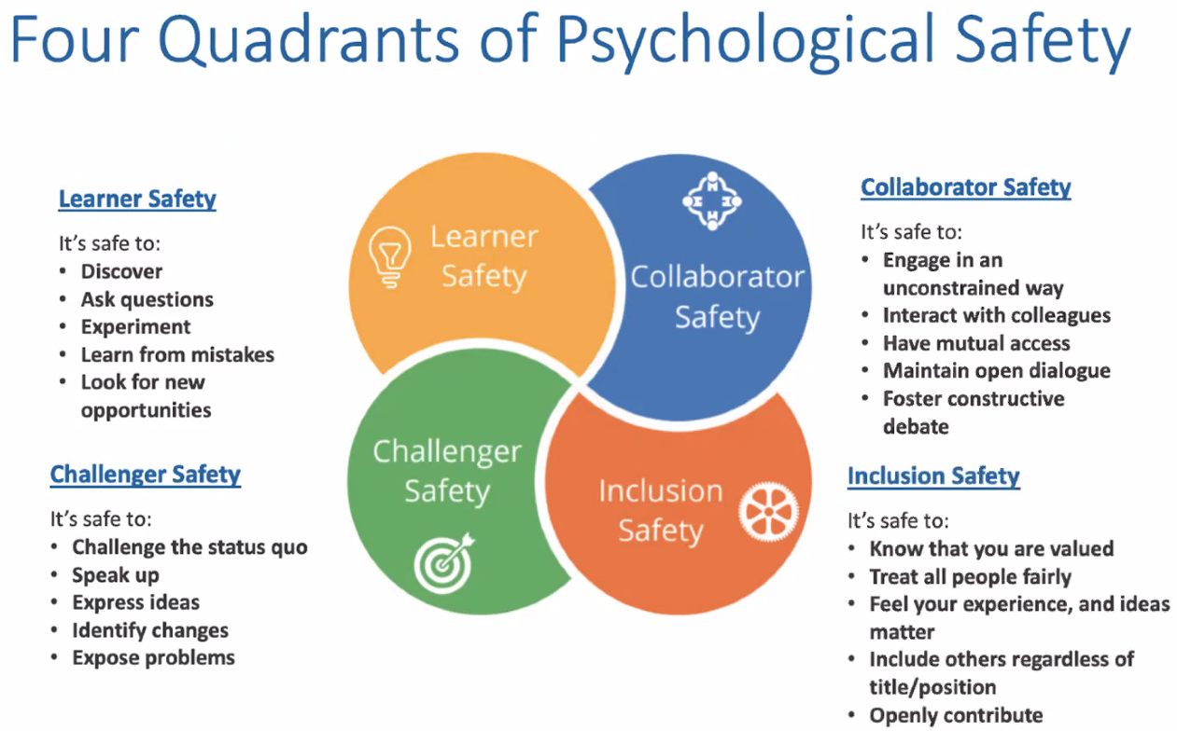

Add something to your above lists (what makes a good team etc.) that you think is missing now you have seen these 2 slides.

Can you guarantee psychological safety? No, you can’t guarantee, but you can do everything possible to try and foster it.

See if you can add a principle to your above lists to help the team recover if there is a flashpoint. Joe’s suggestion is to call it out, but give it space if people need, before coming back to it. Things WILL happen, so you need some way to address it.

## Group Decision Making

The toolkit to make group decisions in uncertainty

Remember agile methodology:



Some decisions have right answers – e.g. Split testing = A vs. B

Most don’t, e.g.:

* How should we execute on this project?
* Which language should we use?
* What should the front end look like?
* What is the best way to structure the architecture?
* How will we work together?

Do it, try it, scrap it, build it.

Think about a time when you were in a team that was struggling to make a decision - what happened to the group dynamic? Joe referenced there may have been a battle of opinions, or trying to make a “perfect” decision, no ownership (so people withdraw),

Why do you think this happens in group decisions? It’s **not** because everyone is an idiot. “The number of perspectives on a situation is equal to the population of the world” Robert McKee

UN’s goals:

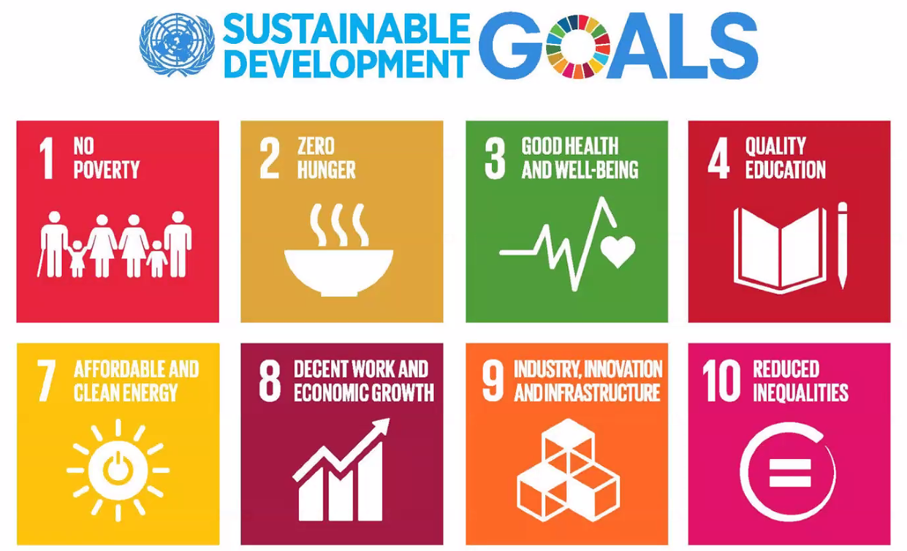

Which do you think should be the top three to focus on? (in order) – I selected 10, 1, 2 starting from most important. 5 and 6 are missing!?

## Dot Voting

2 minutes

You get 6 ‘points’

3 to your top choice

2 to your second choice

1 to your third choice

Useful for when you have a few options, but if you have loads of options you could do several rounds to whittle it down.

We did dot voting in groups on the UN thing:

Everybody marks their top three ideas in order of preference

Add up the totals

## Team Manifesto

Then we were put in to breakout rooms for 10 mins to:

* Create your manifesto
* Start by creating a ‘long-list’ of principles (one person sharing screen)
  + Share your top three principles for working together and your one ‘recovery’ principle
  + If one of your top three is already on the ‘long-list’ then add in a different one from your personal list
* Use dot voting to identify the ones that are most important to the team
* Come up with a top five and one recovery principle

## Roman Voting

Great way to choose between being ready to make a decision or keep discussing it – temperature check.

Thumb up (to make the decision), thumb down (to keep discussing), thumb to the side (indifferent either way)

## First workable option

Told the story of “Sully” – the pilot who landed his plan in the River Hudson. Decision making process – ‘Can we land at an airport? No. Can we land somewhere else on land? No. Can we land on the river? Yes’. So then focussed on making that happen, even if it’s not ideal.

## The 51% rule

Any majority wins, no matter how small (to avoid being tied up).

## Flip a coin!

Heads or Tails to choose between options if we are still completely 50/50.

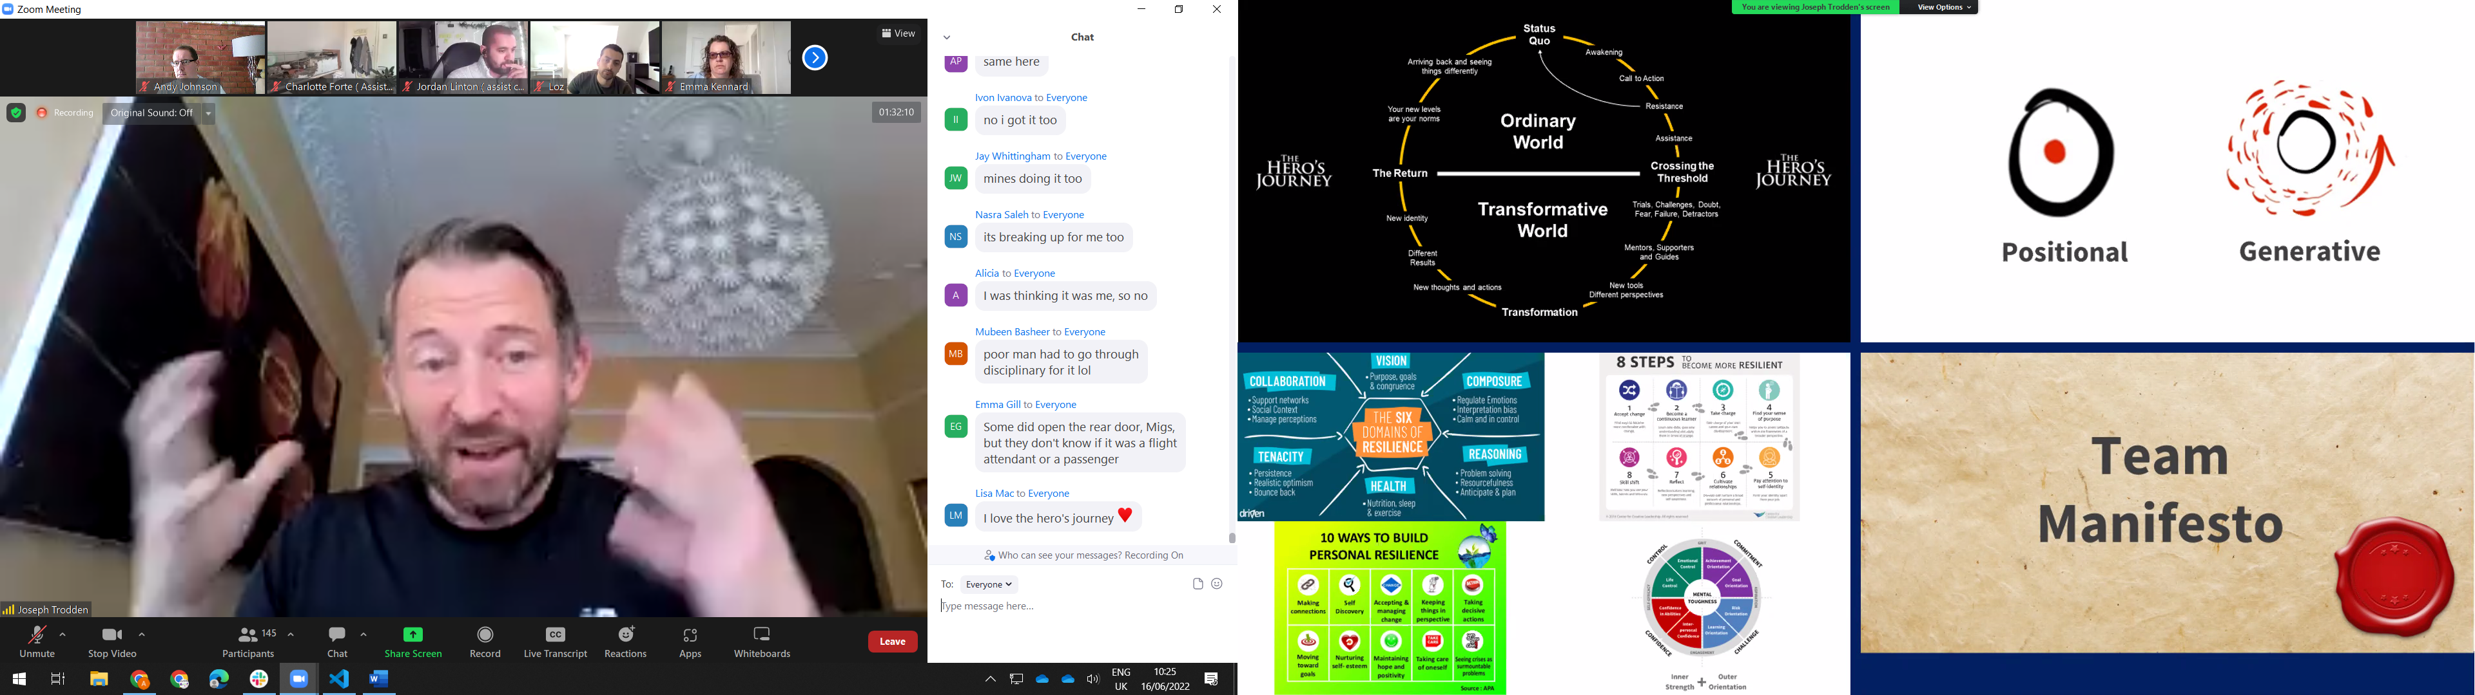

## Summary

* The best teams have great cultures
* Every high-performance team will go off balance – agree a recovery plan?
* Refer back to your manifesto – are you being true to what the group want?
* Group decisions are not about the “right” answer – it’s what the group want to do (so check your ego at the door)
* By the way, there is no right answer…!
* Projects is a Hero’s Journey – make active choices on who you want to become